Importing New Versions of a Graphic File:

Open Graphic Importer and navigate to file you ant to import. Select file.
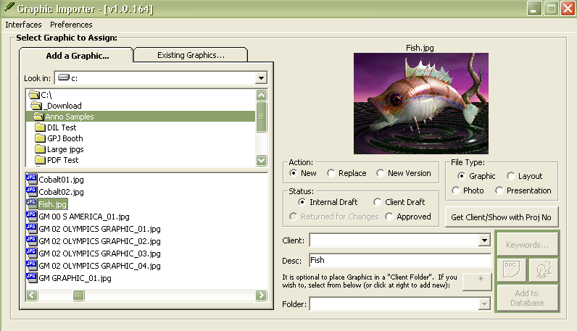

Under the “Action:” option, select “New Version”

The system will attempt to find a matching graphic name. The following screen will pop up.
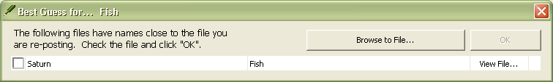

If one of the found files is the one you are replacing, click on the checkbox and click “OK”. Otherwise, click “Browse for file…” if file names do not match. The following will display:
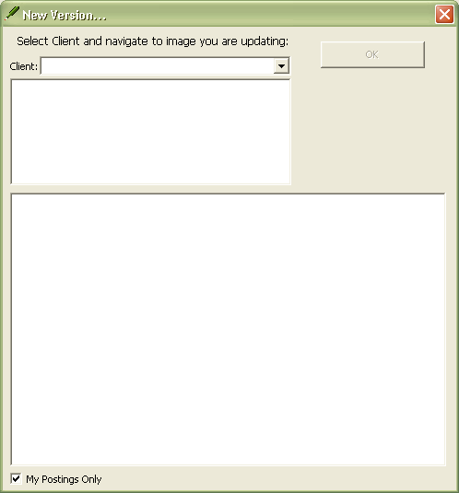

Select “Client:” and Month/Year folder to find file, and click “OK”.
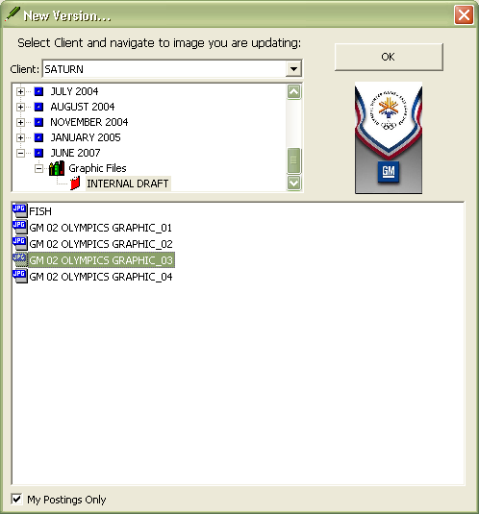

You will now be returned to original Importer interface. Set “Status:”, if different, and click “Add to Database”. Interface will prompt of update.
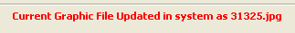

Now if you navigate the “Existing Graphics…” tab to the graphic, you will see a red “V” icon next to the graphic.
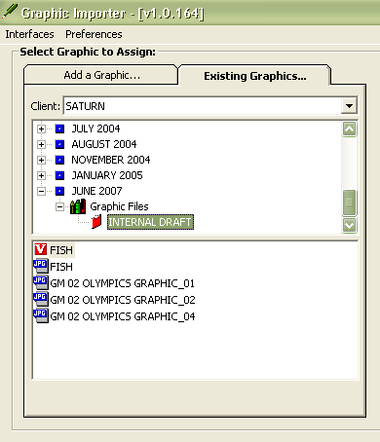

Clicking image in list displays new version, with a “View Multiple Versions…” button displaying.
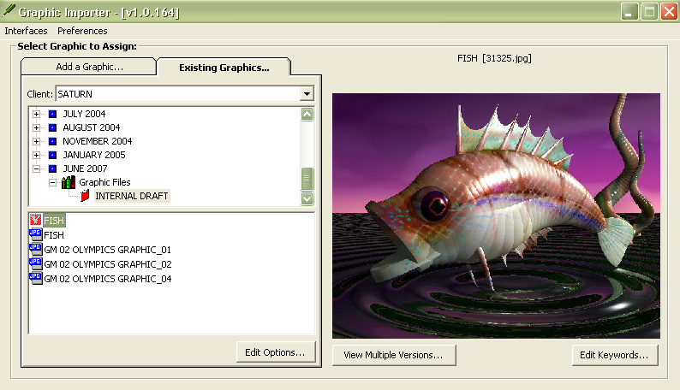

Click “View Multiple Versions…” to display all versions.
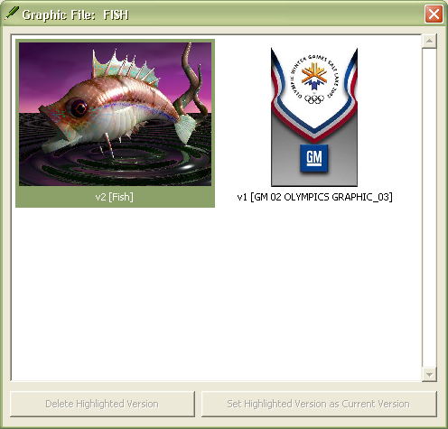

To revert to a former version, click image, and “Set Highlighted Version as Current Version” button will enable. You can also delete old versions from this interface.

Now in the Annotator\Graphics Handler, when the User goes to the “Approval Interface” tab, they will see a red “V” icon next to the image (denoting there are multiple versions).
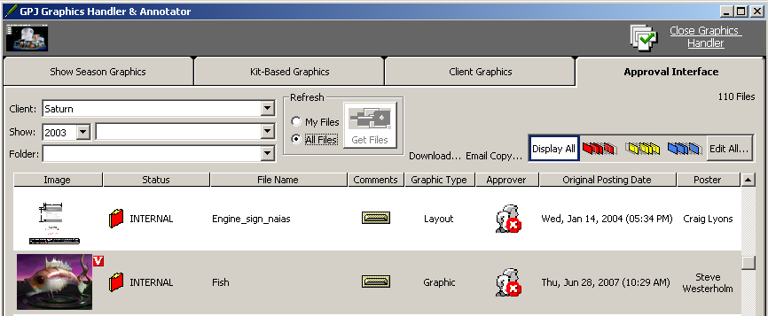
Click on the red “V” to see all versions.
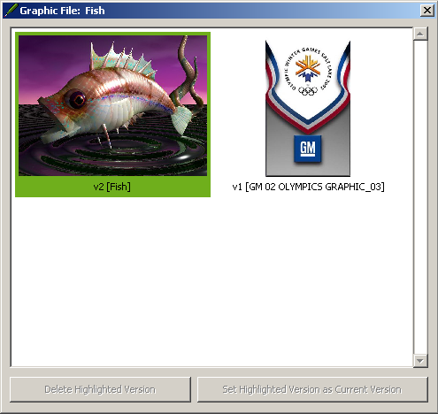

Besides the Graphic Importer, the “Approval Interface” tab is the only place to see past versions. Once “Approved”, past versions can only be seen in the Graphic Importer.

